Journey in Desert

# Assignment 3

## Ramandip Singh 300866240

Contents

Assignment 3 1

Ramandip Singh 300866240 1

Version History 3

Version 1.0.1 3

Version 1.0.2 3

Detailed Game Description 4

Controls 5

Screen description 6

Game Screen 6

Characters 7

1.Player 7

2.Enemy 7

Enemy 8

Problems faced during assignment 9

Problem1: When saving the scene in unity 9

Problem2: When I quit the game. 9

Problem3: During game, my Drive was getting full, and all the data was being lost due to no space. 10

# Version History

## Version 1.0.1

This version only has assets for the time being

## Version 1.0.2

This version has texture and player added.

# Detailed Game Description

It is the game where Player has to go and explore the desert and find the enemy.

# Controls

W: Forward

A: Left

D: Right

S: Backward

Space: Jump

# Screen description

## Game Screen

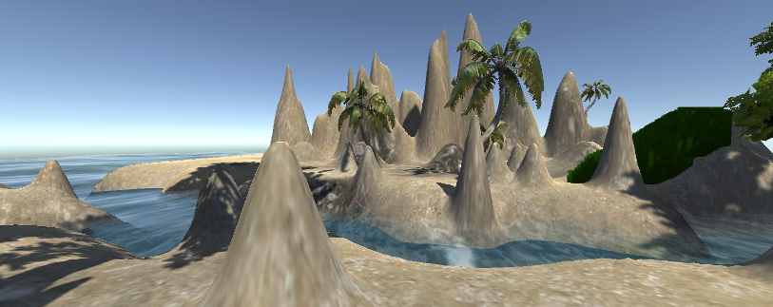

# Characters

## 1.Player

He is the main player of the game. He moves with either WASD/←↓↑→ or mouse movement. As he moves, camera also move along with him.

## 2.Enemy

Enemy is also on the game. He is static at current time.

# Enemy

Enemy is on the same level. Enemy is look like a robot.

# Problems faced during assignment

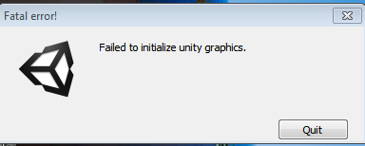

## Problem1: When saving the scene in unity



## Problem2: When I quit the game.

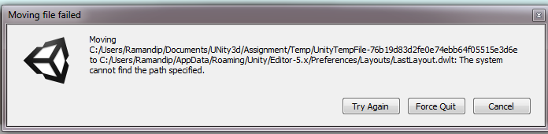

## Problem3: During game, my Drive was getting full, and all the data was being lost due to no space.

